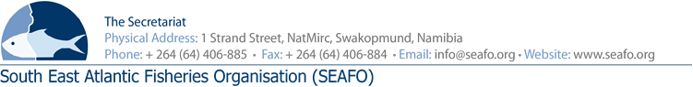

PROVISIONAL AGENDA FOR THE 11TH ANNUAL MEETING OF THE COMPLIANCE COMMITTEE (CC) - 2018

CHAIR: Mr. L Molledo (EU) Venue: Strand Hotel, Swakopmund
VICE-CHAIR: Mr. Ryo Omori (JAPAN) Date: 27 November 2018

 | Agenda Item | Working Document
1 | Opening of Meeting by Chairperson
2 | Appointment of Rapporteur
3 | Adoption of the Agenda and Meeting Arrangements | DOC/CC/00/2018  DOC/CC/01/2018  DOC/CC/02/2018
4 | Introduction of Delegations
5 | Introduction and Admission of Observers
6 | Executive Secretary’s Report on Compliance | DOC/CC/03/2017
7 | Annual review of the “SYSTEM” | DOC/CC/04/2018
8 | Consideration of the provisional SEAFO IUU Vessel list | DOC/CC/05/2018  DOC/CC/06/2018
9 | Recommendations on additional Measures of Compliance
10 | Feedback on Workshops
11 | Any other Matters
12 | Election of New Chair and Vice-Chair
13 | Venue and date of next meeting
14 | Adoption of the Compliance Committee Report
15 | Closure of meeting

Circulation Date: 27 October 2018

